|  |  |  |  |
| --- | --- | --- | --- |
| Case | Target | Method | Status |
| As a teacher I want to create a new student | RealStudent | RealStudent(String name, String cpr, Parent parent); | PASS |
| As a teacher I want to set/change the name of a student | RealStudent | setName(String name); | PASS |
| As a teacher I want to get the name of a student | RealStudent | getName(); | PASS |
| As a teacher I want to add grades to the subject of a student | Subject | Subject(String type); | PASS |
| As a teacher I want to set the attendence of a subject | Subject | setAttendence(String attendence); | PASS |
| As a teacher I want to get the attendence of a subject | Subject | getAttendence(); | PASS |
| As a teacher I want to set/change the grades of a subject | Subject | setGrades(); | PASS |
| As a teacher I want to get the grades of a subject | Subject | getGrades(); | PASS |

# Flyweight Testing

To test the Flyweight, an object is created, and this object is tracked by its hashcode, thus, when creating other objects, it is checked if the same object is used in creating them.

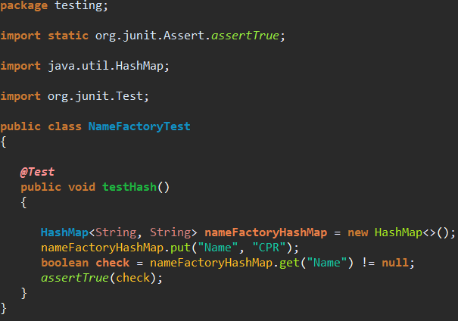

|  |  |  |  |
| --- | --- | --- | --- |
| Case | Target | Method | Status |
| As an admin I want to create a new teacher/  As a teacher I want to create a new student&parent | Person | Person(String name, String cpr); | PASS |
| As an admin I want to get the name of a teacher/ As a teacher I want to get the name of student or parent | Person | getName(); | PASS |
| As an admin I want to set/change the name of a teacher/ As a teacher I want to set the name | Person | setName(String value); | PASS |
| As an admin I want to get the CPR of a teacher/ As a teacher I want to get the CPR of a student or parent | Person | getCPR(); | PASS |
| As an admin I want to set/change the CPR of a teacher/ A teacher I want to set/change the CPR of a student or parent | Person | setCPR(String value); | PASS |
| Flyweight has to create a name instance | Name | Name(String name); | PASS |
| Flyweight has to get a name instance | Name | getName(); | PASS |
| Flyweight has to set a name instance | Name | setName(String name); | PASS |
| Flyweight has to create a CPR instance | CPR | CPR(String cpr); | PASS |
| Flyweight has to get a CPR instance | CPR | getCPR(); | PASS |
| Flyweight has to set a CPR instance | CPR | setCPR(); | PASS |

# Singleton Testing

To test the Singleton, two School objects are created and then the Hash Code of them is compared, and if Singleton is working properly, then the Hash Code should be identical.

